ARCHITECTURE OF FLIGHT BOOKING SYSTEM

PHYSICAL TIERS LOGICAL TIERS AND LAYERS



Client Tier



Middle Tier



Data Tier

Presentation layer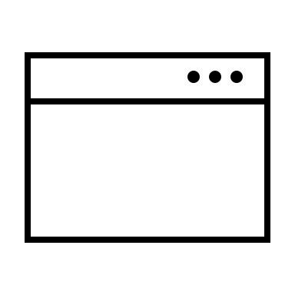

URL Single page App

UI Web Service

Next.js client .NET (C#)

APPLICATION SERVER



MongoDB

React.js

DAO (Persistence) layer

Business layer

Service layer